## **Name: Javeria Manzoor**

**Roll no: BSAI-3C-201**

**Subject:Artificial Intelligence(LAB)**

**Task no:02**

**Submitted to : Sir Rasikh**

## **Mini Project 1: Fizz Buzz**

### **How It Works (Step-by-Step)**

1. **for number in range(1, 101):** This loop runs from **1 to 100**, covering all rounds.
2. **number % 3 == 0** The % operator gives the **remainder** of a division.  
   * If the remainder is 0, that means the number is **divisible** by that number.
   * Example: 9 % 3 == 0 (9 is divisible by 3)
3. **Condition Order Matters:**
   * First, we check **both 3 and 5**, because numbers like 15, 30, 45, etc., should print **“Fizz Buzz”**, not just one.
   * Then check for 3 and 5 separately.
4. **Printing the Result:**
   * Based on which condition matches, we print "Fizz", "Buzz", "Fizz Buzz", or the number itself.

### **Why**

* Uses only **basic Python (no imports)**
* Shows clear **logical flow**
* Works perfectly in **VS Code** or any Python IDE
* Very **easy to modify** (e.g., you can change the range or words)

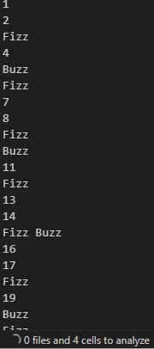

**Mini Project 2 – Movie Budget Analysis**

### **How the Works**

1. **Movie Data (Tuples)** Each movie is stored as a tuple:  
    ("Movie Name", budget)  
   **User Input (Optional)** The user can add more movies to the list dynamically using append().
2. **Average Calculation**
   * Adds all budgets together.
   * Divides by total number of movies.  
     **Comparison & Printing**
   * Checks which movies have a budget **greater than the average**.
   * Prints how much higher their budgets are.

